**Jenkins setup**

* Launch 2 instances (Master and slave)
* Run the below command on master
  + sudo apt update -y
  + sudo apt install openjdk-17-jre -y (install java 17 and above)
  + java --version
* Download Jenkins from the below site
  + <https://www.jenkins.io/doc/book/installing/linux/>
  + go with the Long Term Support release
* Commands to

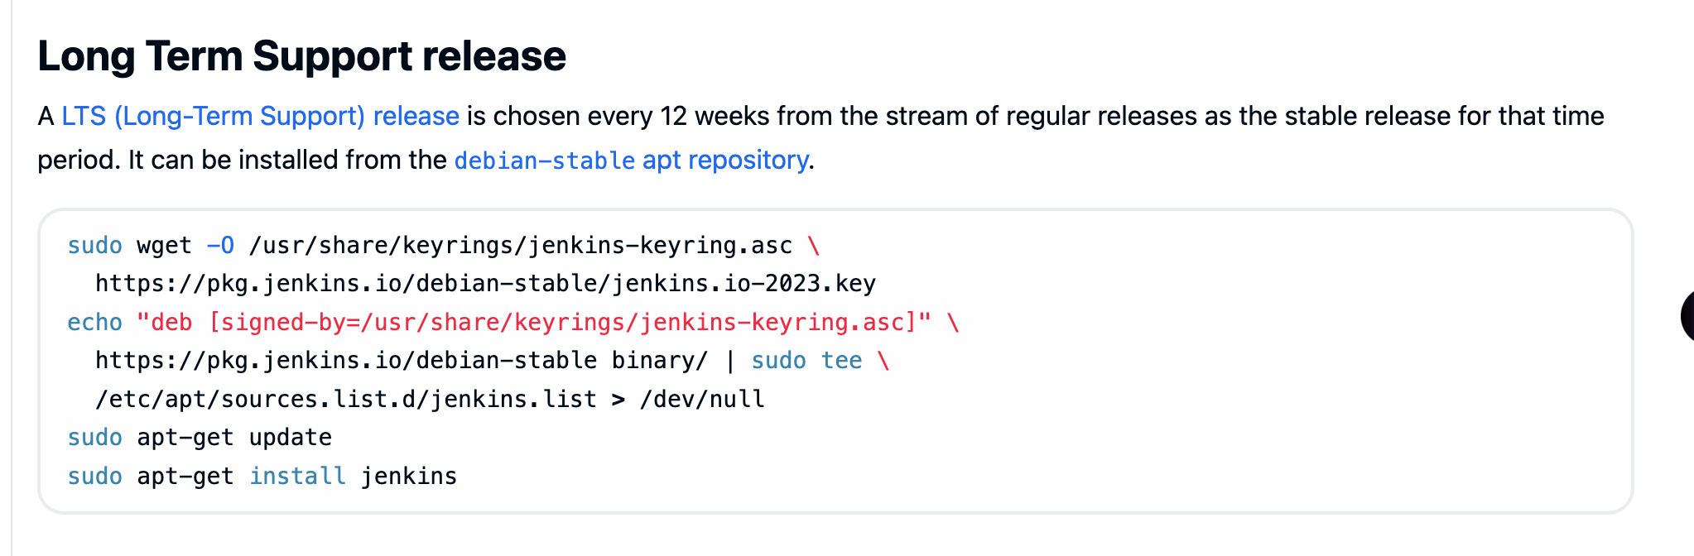

* Start Jenkins  
  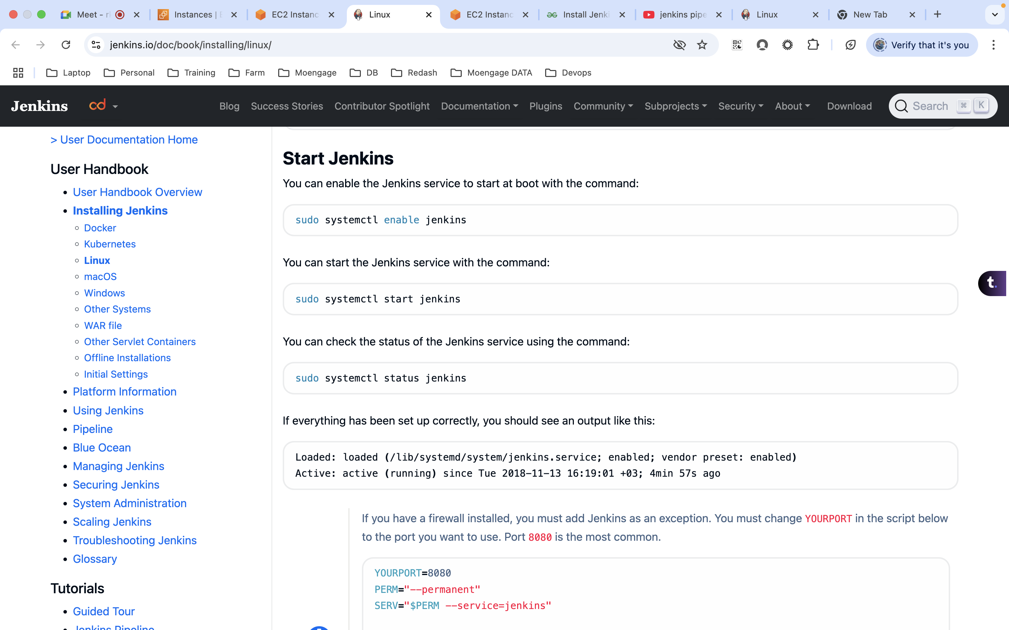

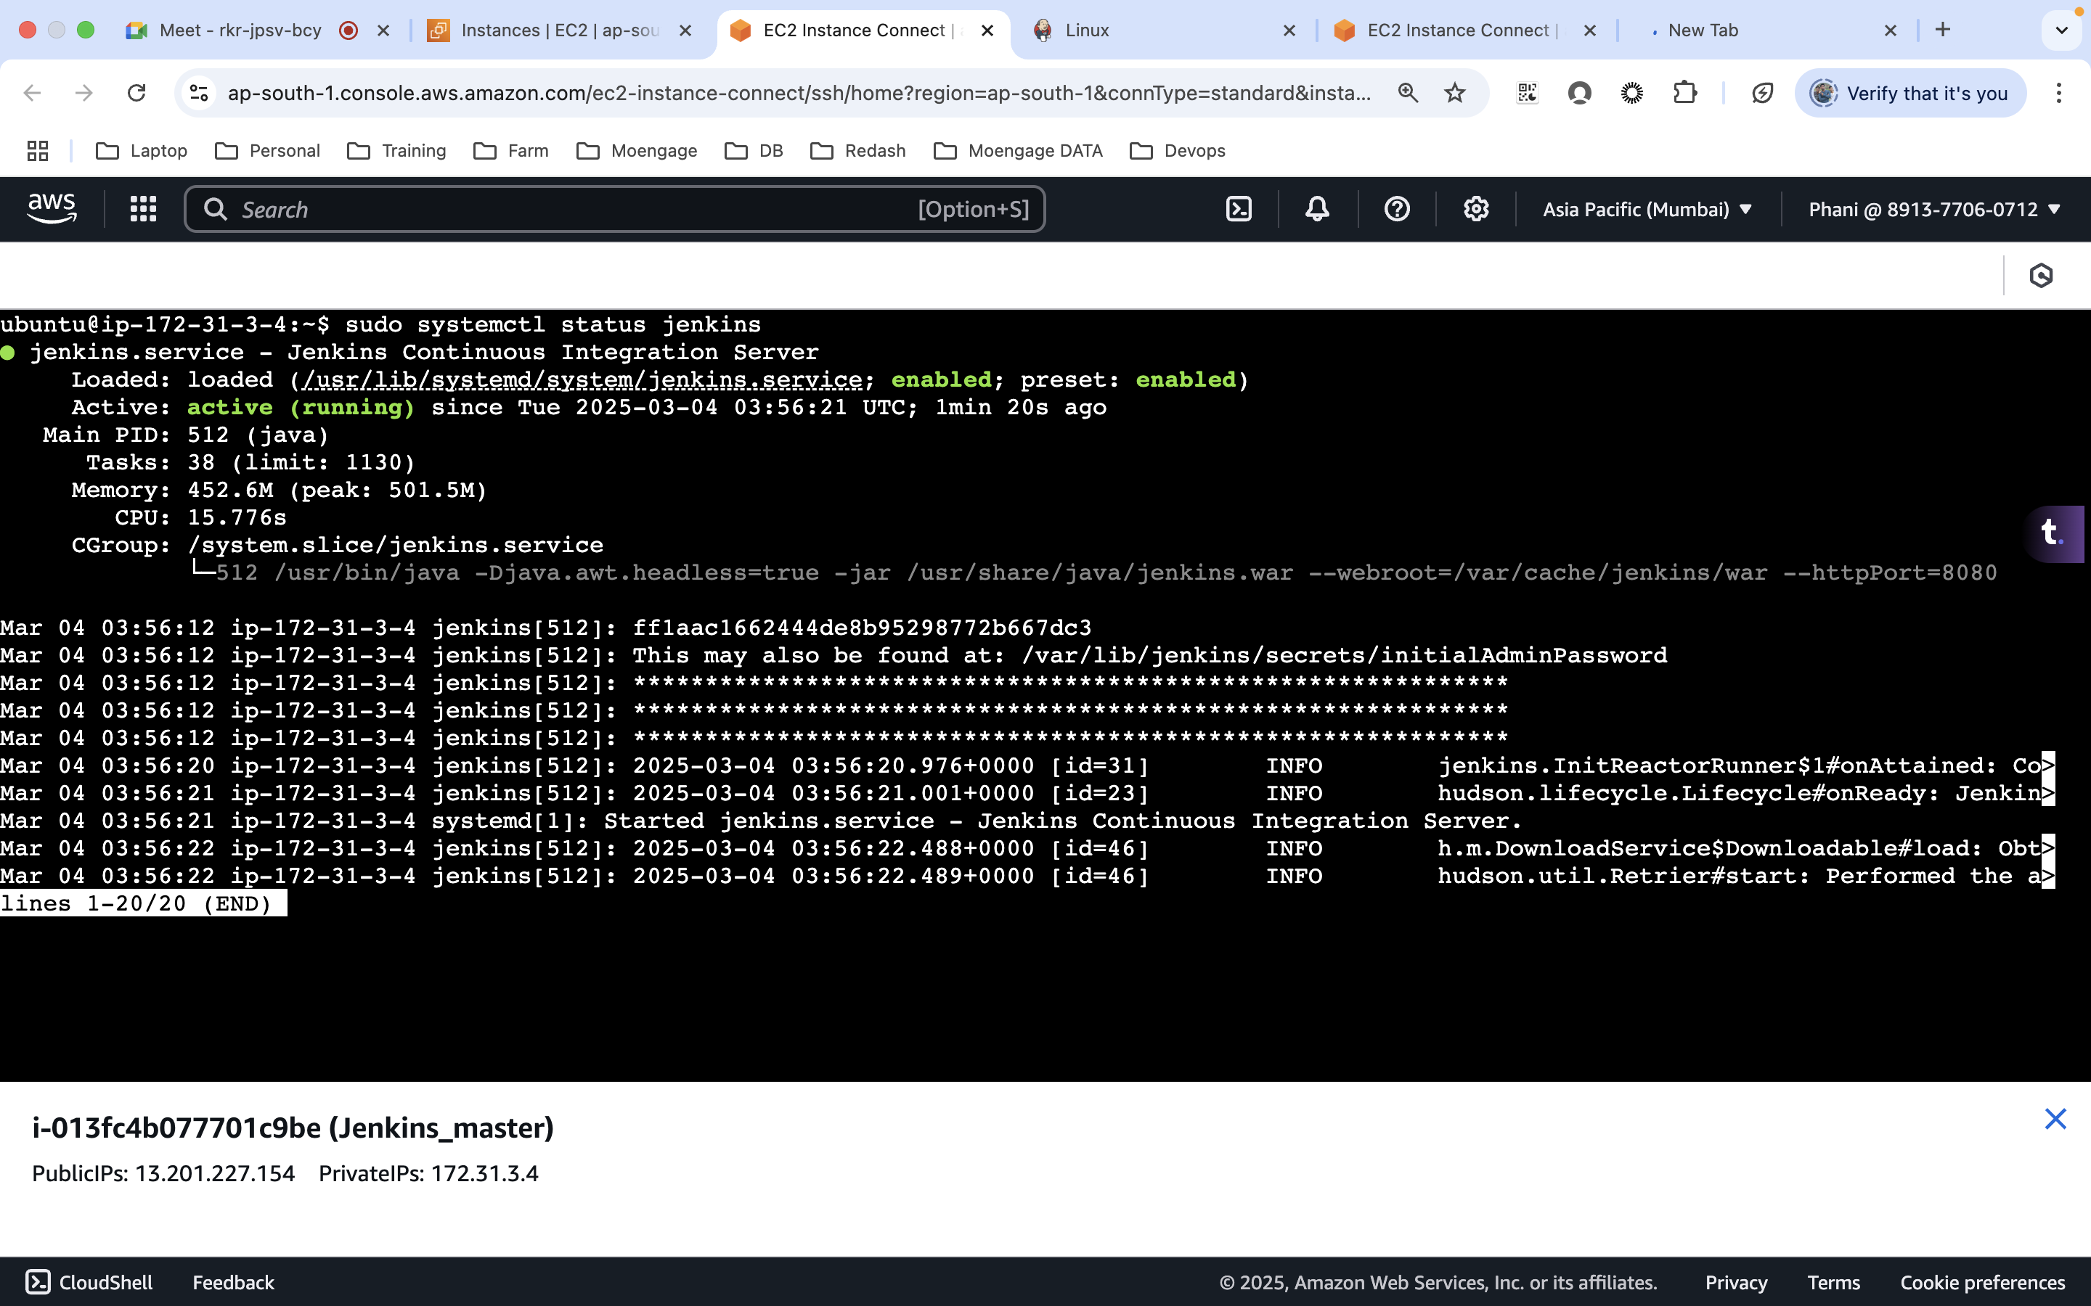

* Add a inbound rule with port 8080  
  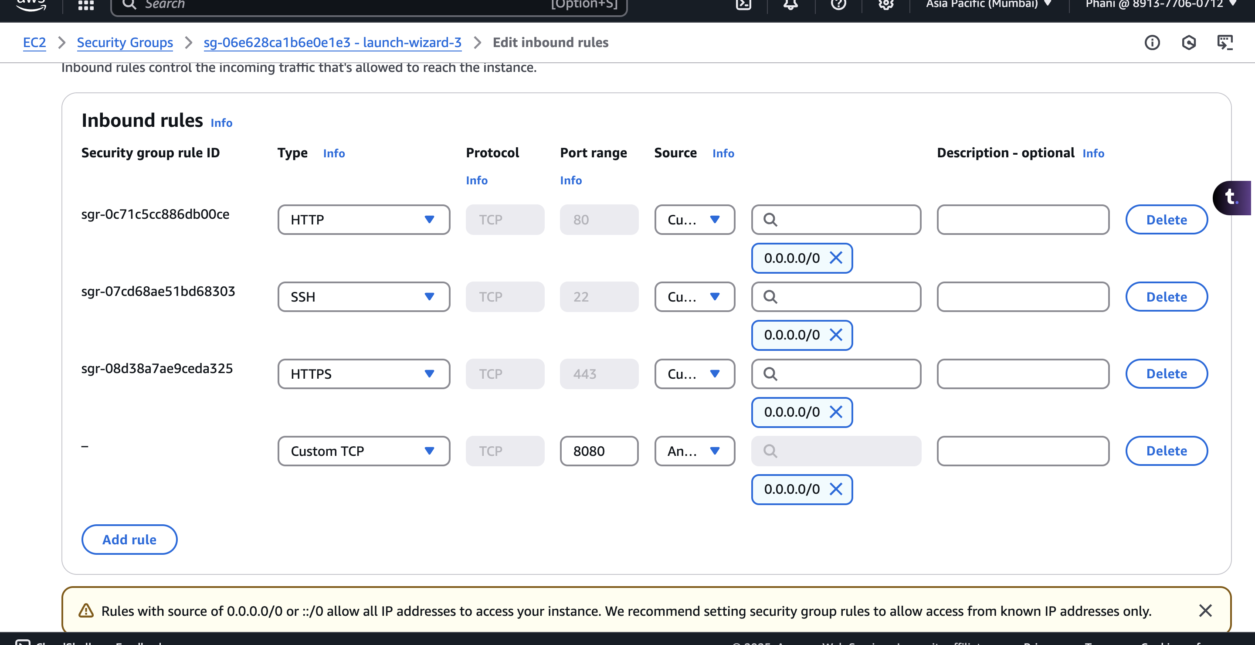
* By default, Jenkins will be running on 8080 port
* Use publicip:8080
  + initially it will ask for the password from a specific location and the location will be displayed
  + install suggested plugins  
    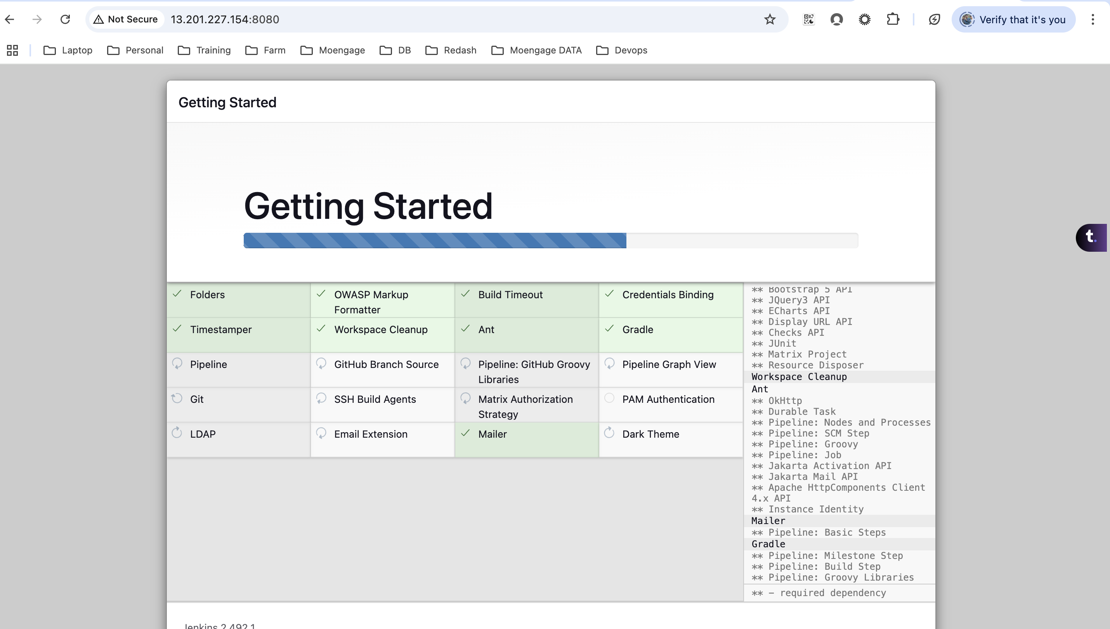

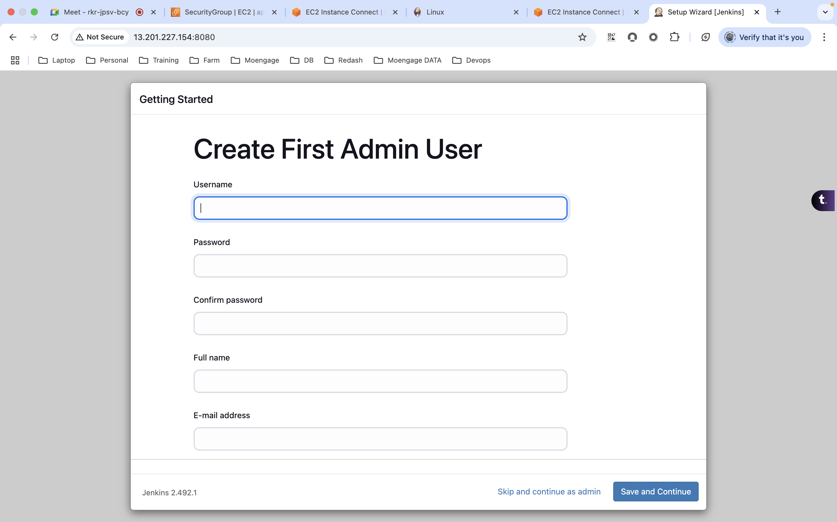

phani

admin123

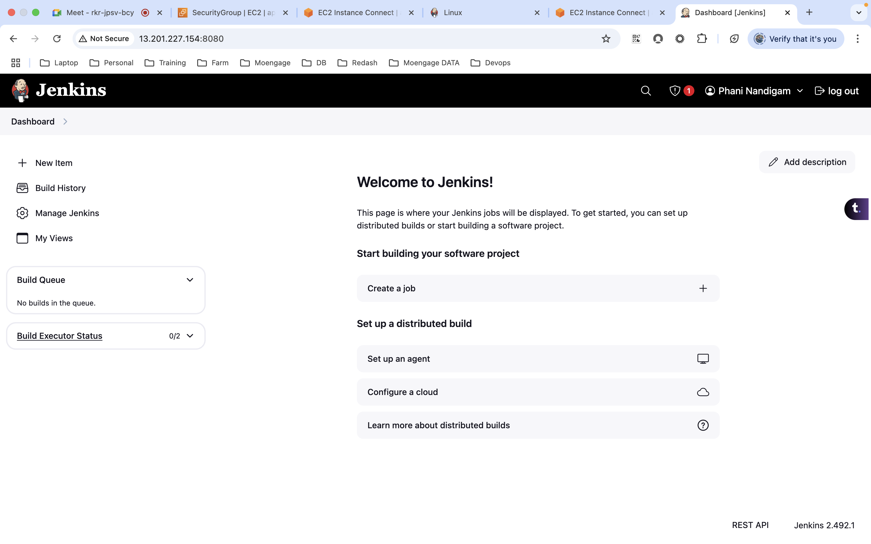

* On Slave:
* commands
  + sudo apt update -y
  + sudo apt install openjdk-17-jre -y
  + java –version
  + change to root user (sudo su)
  + ssh-keygen
    - this will generate the ssh keys as a root user  
      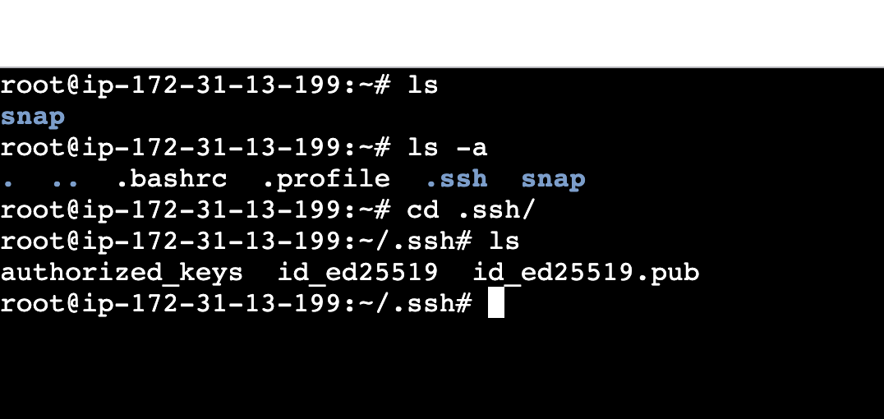
  + copy the public key from .pub to the authorized keys  
    A screenshot of a computer

    AI-generated content may be incorrect.
  + copy the private key and keep it aside
  + create a new directory ‘jenkins’ under /opt
  + we can use any folder here
  + provide the full permissions for the created directory  
    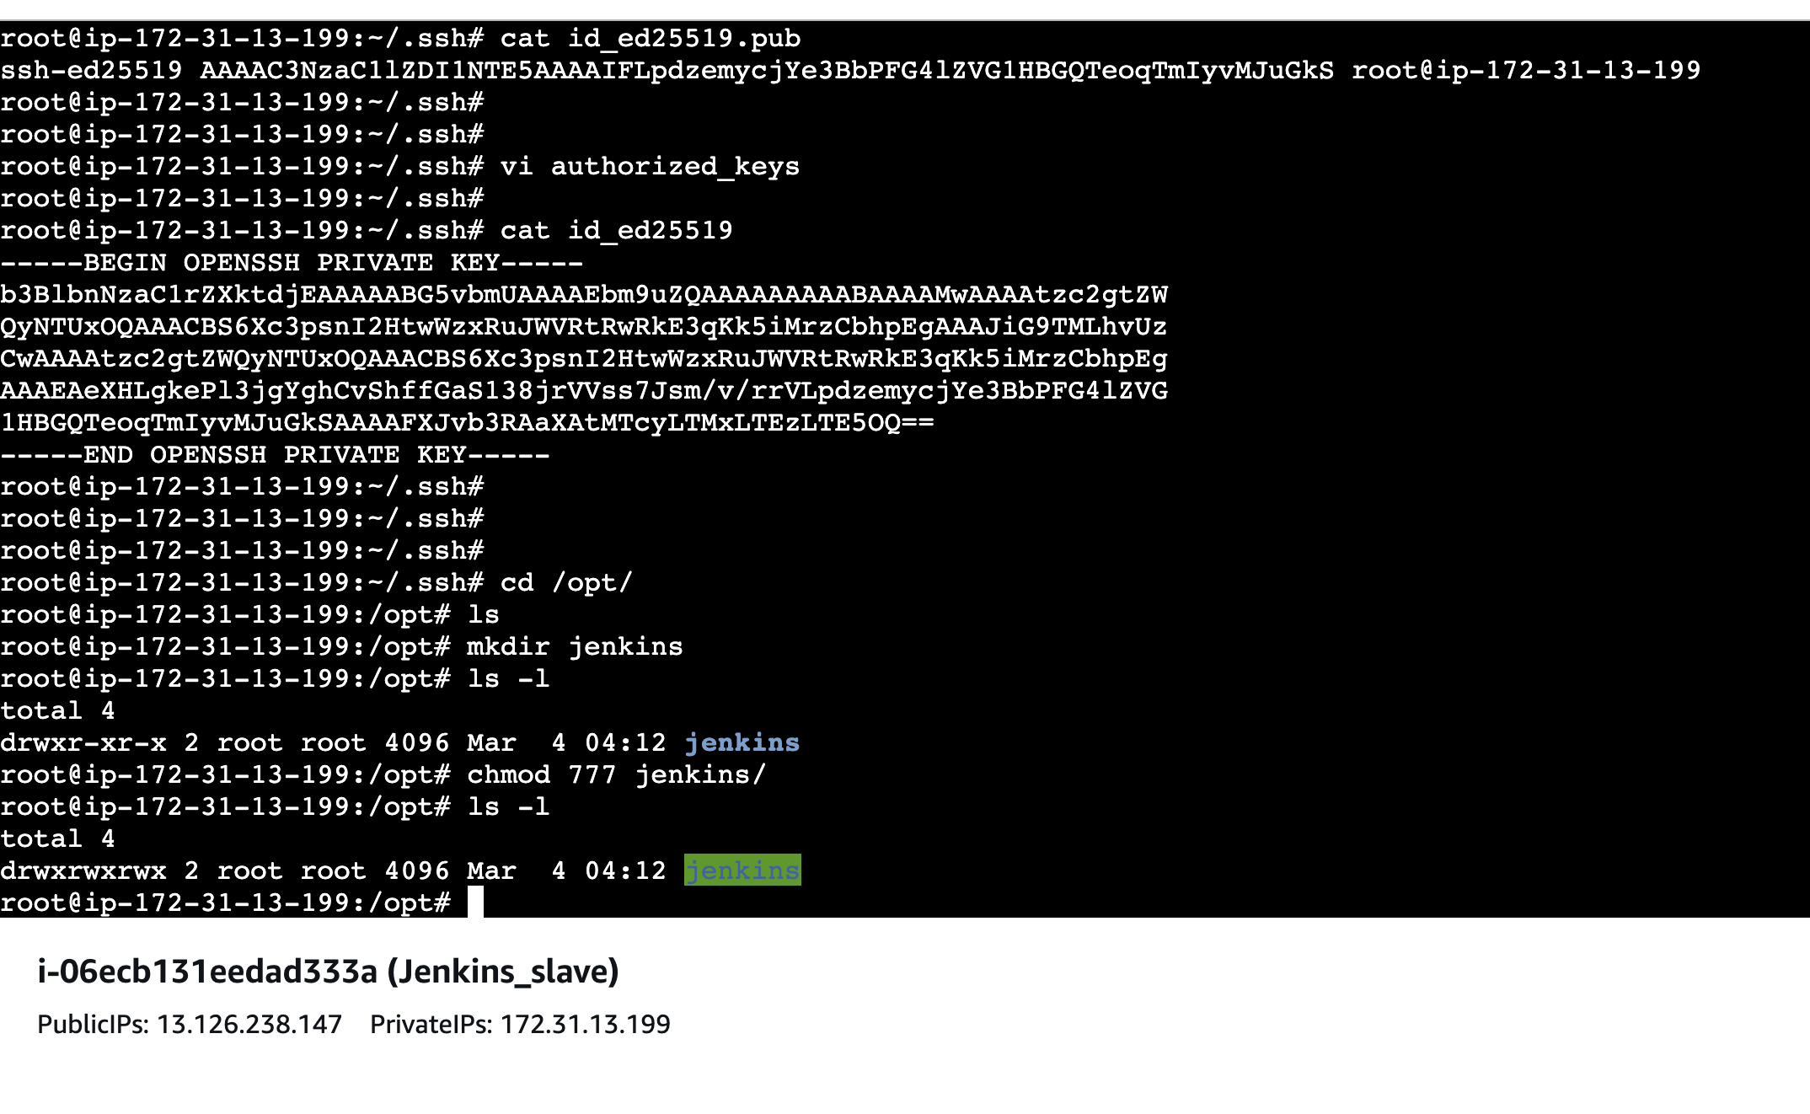
* Now let add the slave to the master
* First we need to add the credentials and add the node
* Steps
  + on Master Jenkins page
  + click on manage Jenkins
  + click on credentials
  + click on global domain
  + click on add credentials
  + Kinds  
    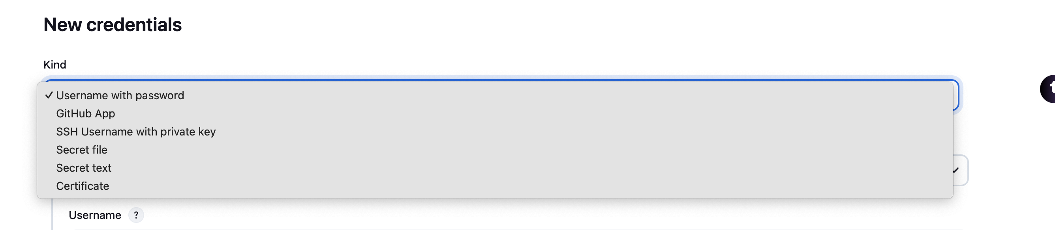
  + use ssh username and privte key kind
  + ID can be anything, username has to be root(We have generated the keys using root profile on the slave)  
    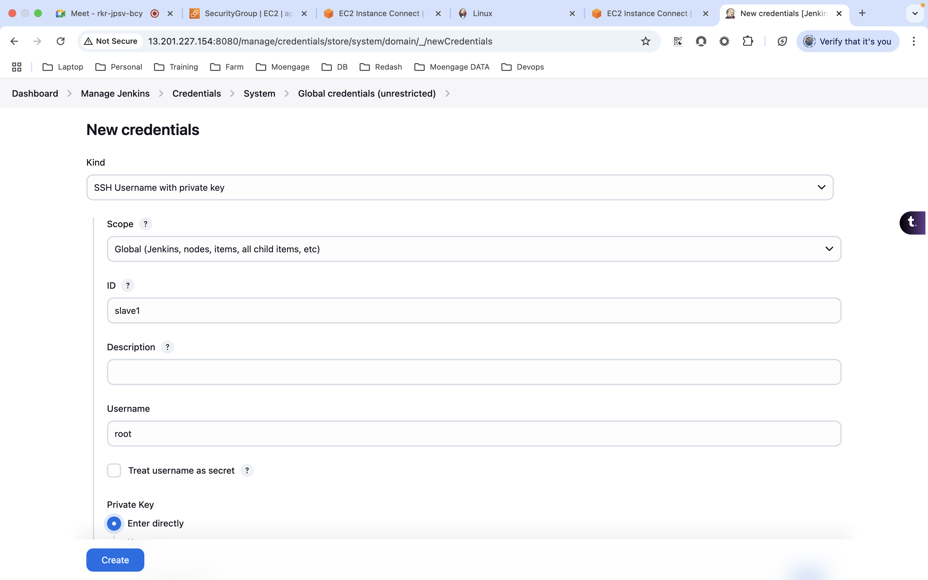

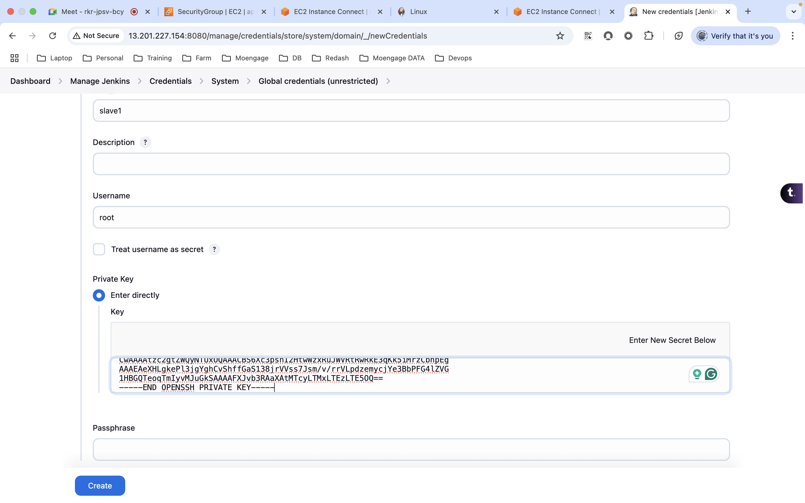

* Add node  
  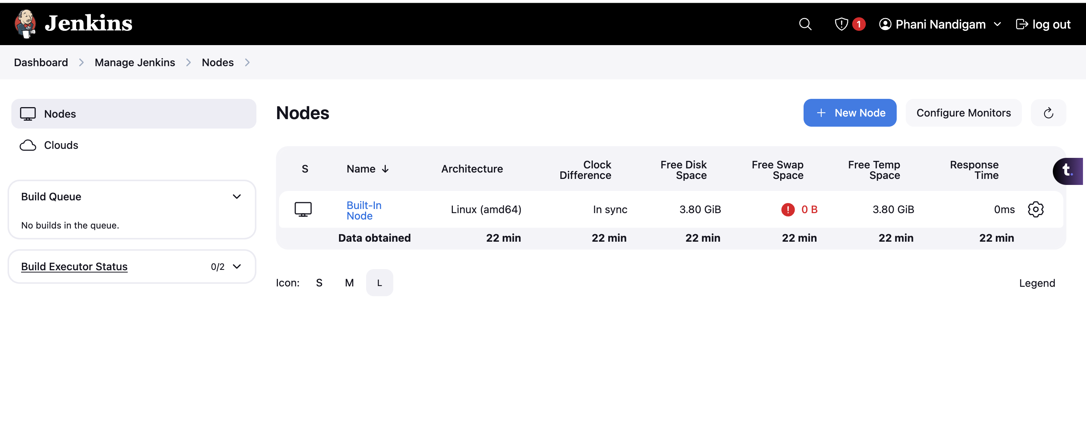  
  A screenshot of a computer

  AI-generated content may be incorrect.
* Remote root will be the directory which we have created, host will be the private ip of the slave and under credentials, select the one which we have created earlier.  
  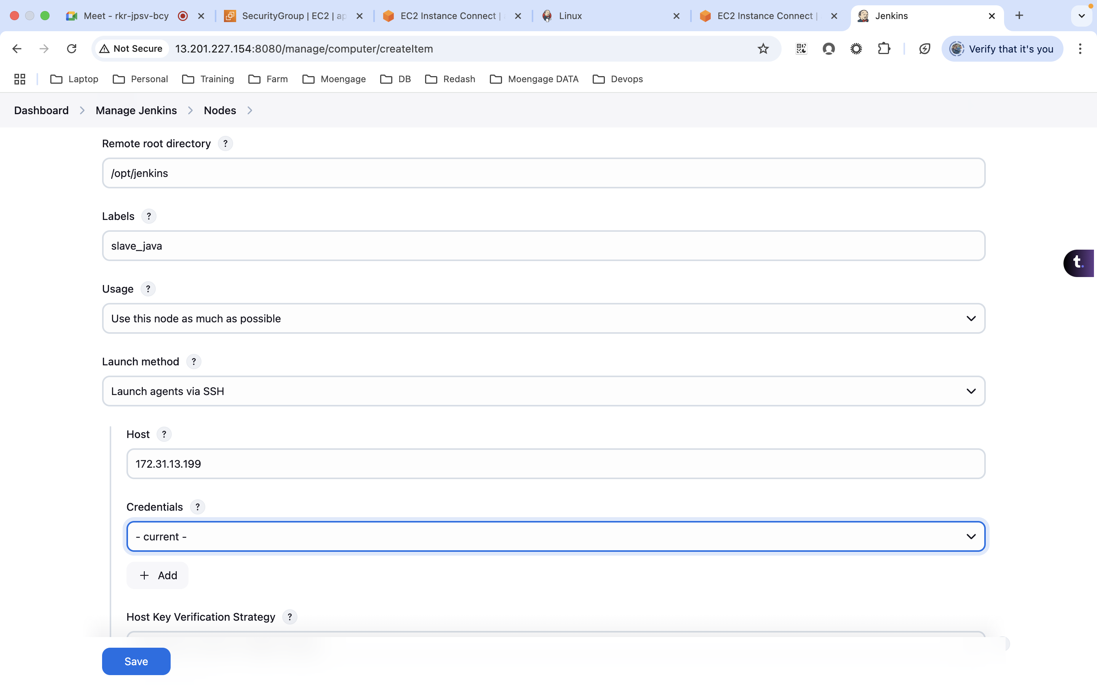
* A blue line on a white sheet

  AI-generated content may be incorrect.
* under log  
  